# City of Jacksonville Tuesday, May 20, 2025

**12:30 PM**

**117 W. Duval Street** **Jacksonville, FL 32202**

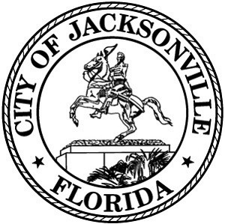**Council Chamber, 1st Floor, City Hall**

**Special Committee on Duval DOGE**

**Agenda**

**May 20, 2025**

**12:30 PM**

**City Council Chamber**

## Call to Order and Introductions

1. Administration – Procurement Card Presentation
2. CIP – Status Update and Proposed Legislation
3. City Facilities – (Libraries, Senior Centers, and Community Centers)
4. Questions and Comments
5. Adjourn

Page 1 of 1